

### Semester Two Examination, 2019

### Question/Answer booklet

# MATHEMATICS

**APPLICATIONS**

**UNITS 3 AND 4**

## Section Two:

## Calculator-assumed

| Student number: In figures |  |  |  |  |  |  |  |  |  |  |
| --- | --- | --- | --- | --- | --- | --- | --- | --- | --- | --- |

In words

Your name

## Time allowed for this section

Reading time before commencing work: ten minutes

Working time: one hundred minutes

## Materials required/recommended for this section

***To be provided by the supervisor***

This Question/Answer booklet

Formula sheet (retained from Section One)

***To be provided by the candidate***

Standard items: pens (blue/black preferred), pencils (including coloured), sharpener,  
correction fluid/tape, eraser, ruler, highlighters

Special items: drawing instruments, templates, notes on two unfolded sheets of A4 paper, and up to three calculators approved for use in this examination

## Important note to candidates

No other items may be taken into the examination room. It is **your** responsibility to ensure that you do not have any unauthorised material. If you have any unauthorised material with you, hand it to the supervisor **before** reading any further.

## Structure of this paper

| Section | Number of questions available | Number of questions to be answered | Working  time (minutes) | Marks available | Percentage of examination |
| --- | --- | --- | --- | --- | --- |
| Section One:  Calculator-free | 8 | 8 | 50 | 52 | 35 |
| Section Two:  Calculator-assumed | 13 | 13 | 100 | 98 | 65 |
|  | | |  | **Total** | 100 |

## Instructions to candidates

1. The rules for the conduct of examinations are detailed in the school handbook. Sitting this examination implies that you agree to abide by these rules.

2. Write your answers in this Question/Answer booklet preferably using a blue/black pen.  
Do not use erasable or gel pens.

3. You must be careful to confine your answer to the specific question asked and to follow any instructions that are specified to a particular question.

4. Show all your working clearly. Your working should be in sufficient detail to allow your answers to be checked readily and for marks to be awarded for reasoning. Incorrect answers given without supporting reasoning cannot be allocated any marks. For any question or part question worth more than two marks, valid working or justification is required to receive full marks. If you repeat any question, ensure that you cancel the answer you do not wish to have marked.

5. It is recommended that you do not use pencil, except in diagrams.

6. Supplementary pages for planning/continuing your answers to questions are provided at the end of this Question/Answer booklet. If you use these pages to continue an answer, indicate at the original answer where the answer is continued, i.e. give the page number.

7. The Formula sheet is not to be handed in with your Question/Answer booklet.

**Section** **Two: Calculator-****assumed** **65% (****98 Marks)**

This section has**thirteen (****13)** questions. Answer **all** questions. Write your answers in the spaces provided.

Working time: 100 minutes.

**Question 9 (6 marks)**

| **Solution** |
| --- |
|  |
| **Specific behaviours** |
| ✔ indicates use of Euler's formula  ✔ correct number |

(a) Connected planar graph has faces and edges. Determine the number of vertices has. (2 marks)

(b) Draw graph so that it has vertices, is a tree and is not semi-Eulerian. (2 marks)

| **Solution** |
| --- |
| *(example solution)* |
| **Specific behaviours** |
| ✔ tree using 6 vertices  ✔ not semi-Eulerian |

(c) Graph is shown below. Redraw to clearly show that it is bipartite, underlining vertex and the other vertices that belong to its group. (2 marks)



| **Solution** |
| --- |
| *(example solution)* |
| **Specific behaviours** |
| ✔ clearly bipartite  ✔ underlines and |

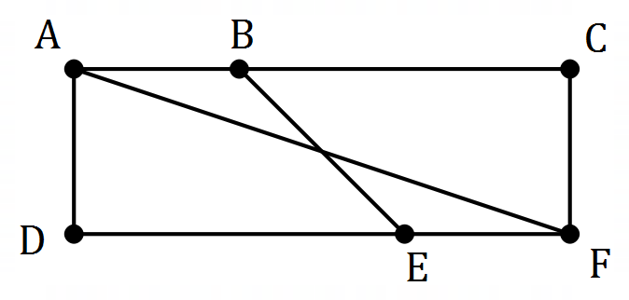

**Question 10 (6 marks)**

The number of tickets remaining for a musical event at the start of day can be modelled by the recursive rule . At the start of day , there were tickets remaining.

(a) Complete the table below. (2 marks)

|  |  |  |  |  |
| --- | --- | --- | --- | --- |
|  |  |  |  |  |

| **Solution** |
| --- |
| See table |
| **Specific behaviours** |
| ✔ at least two correct entries  ✔ all correct entries |

(b) Would the graph of against appear to be linear or non-linear? (1 mark)

| **Solution** |
| --- |
| Linear |
| **Specific behaviours** |
| ✔ correct type |

| **Solution** |
| --- |
| Hence and . |
| **Specific behaviours** |
| ✔ value of  ✔ value of |

(c) The th term rule for this sequence is . Determine the value of the constant and the value of the constant . (2 marks)

(d) At the start of day , fewer than tickets remain. State the value of . (1 mark)

| **Solution** |
| --- |
|  |
| **Specific behaviours** |
| ✔ correct value |

**Question 11 (11 marks)**

The scatterplot and table below show the length () and the weight () of some mackerel, a species of fish.

| (cm) |  |  |  |  |  |  |  |  |  |  |  |  |
| --- | --- | --- | --- | --- | --- | --- | --- | --- | --- | --- | --- | --- |
| (kg) |  |  |  |  |  |  |  |  |  |  |  |  |

(a) By viewing a scatterplot of this data on your calculator, identify and describe the direction and form of the relationship between the variables. (2 marks)

| **Solution** |
| --- |
| Direction is positive and form is linear. |
| **Specific behaviours** |
| ✔ states positive direction  ✔ states linear form |

(b) Calculate the correlation coefficient between the variables and use it to describe the strength of their association. (2 marks)

| **Solution** |
| --- |
| .  Hence the strength of association is strong. |
| **Specific behaviours** |
| ✔ correct coefficient  ✔ states strong association |

| **Solution** |
| --- |
|  |
| **Specific behaviours** |
| ✔ correct percentage |

(c) What percentage of the variation in weight can be explained by the variation in the length for this sample? (1 mark)

(d) Using length as the explanatory variable, determine the equation of the least-squares line to model the linear relationship between the variables. (2 marks)

| **Solution** |
| --- |
|  |
| **Specific behaviours** |
| ✔ correct coefficients  ✔ uses correct variables |

| **Solution** |
| --- |
| kg or grams |
| **Specific behaviours** |
| ✔ weight with units |

(e) What increase in weight can be expected for each additional centimetre in length for these mackerel? (1 mark)

(f) Another mackerel in the sample had a length of cm. Predict the weight of this fish and comment on two factors that support the reliability of this prediction. (3 marks)

| **Solution** |
| --- |
| kg. Reliable because a strong linear association exists, and prediction is interpolated. |
| **Specific behaviours** |
| ✔ correct prediction  ✔ notes interpolation  ✔ notes strong association |

**Question 12 (6 marks)**

An investor is considering placing the sum of into one of three investments for years.

Investment A offers a return of compounded quarterly.

(a) Determine the profit that the investor would achieve through investment A. (2 marks)

| **Solution** |
| --- |
|  |
| **Specific behaviours** |
| ✔ future value  ✔ profit |

Investment B offers a return of compounded daily.

(b) Calculate the difference in profit that the investor would achieve through investment B compared to investment A. (2 marks)

| **Solution** |
| --- |
|  |
| **Specific behaviours** |
| ✔ future value for B  ✔ difference |

Investment C offers a return of compounded monthly.

(c) Rank the three investments in order, from highest to lowest profit. Justify your answer.

| **Solution** |
| --- |
| Effective interest rates are:  Ranking: |
| **Specific behaviours** |
| ✔ effective rates or other comparison  ✔ correct ranking (must be justified) |

(2 marks)

**Question 13 (6 marks)**

A random sample of TAFE students studying the same diploma was taken. Their study mode and enjoyment of the course is summarised in the table below.

|  | | Study mode | |
| --- | --- | --- | --- |
| Attend campus | Online |
| Level of course enjoyment | High |  |  |
| Moderate |  |  |
| Low |  |  |
| None |  |  |

| **Solution** |
| --- |
|  |
| **Specific behaviours** |
| ✔ column total  ✔ shows percent calculation |

(a) Show that the study mode of approximately of the students in the sample is to attend campus. (2 marks)

(b) Complete the two-way frequency table below to show the column percentages for the above data, rounding to the nearest whole number. (2 marks)

|  | | Study mode | |
| --- | --- | --- | --- |
| Attend campus | Online |
| Level of course enjoyment | High |  |  |
| Moderate |  |  |
| Low |  |  |
| None |  |  |

| **Solution** |
| --- |
| See table (no penalty if not rounded) |
| **Specific behaviours** |
| ✔ all values in one column  ✔ both columns correct |

(c) Explain whether the data suggests the presence of an association between the variables.

(2 marks)

| **Solution** |
| --- |
| No evidence that level of course enjoyment for this diploma is associated with study mode because across all four rows, both values are very similar. |
| **Specific behaviours** |
| ✔ states no association  ✔ explanation for no association |

**Question 14 (5 marks)**

A young person has a bank account that pays no interest. At the start of each week they withdraw a fixed percentage of the balance to spend and then deposit a lump sum from their wages. The balance of the account at the end of week is given by , where

(a) Calculate and explain what this figure represents.

| **Solution** |
| --- |
| This is the amount in the account at the end of week . |
| **Specific behaviours** |
| ✔ amount to nearest cent  ✔ explanation |

(2 marks)

(b) State what percentage of the balance they withdraw each week. (1 mark)

| **Solution** |
| --- |
|  |
| **Specific behaviours** |
| ✔ correct percentage |

(c) The young person plans to continue operating the account in this manner until it holds at least . Comment on this plan. (2 marks)

| **Solution** |
| --- |
| Not possible for the balance of this account to exceed (long term steady state) and so plan is not realistic. |
| **Specific behaviours** |
| ✔ states maximum account balance  ✔ makes sensible comment |

**Question 15 (8 marks)**

A delivery driver must leave depot at am, deliver packages to three schools (, and ) and then return to the depot. The table below shows the travel times between the various locations in minutes.

|  |  |  |  |
| --- | --- | --- | --- |
|  |  |  |  |
|  |  |  |  |
|  |  |  |  |

(a) Construct a weighted graph to represent this information. (3 marks)

| **Solution** |
| --- |
| (example solution) |
| **Specific behaviours** |
| ✔ four labelled vertices  ✔ six edges  ✔ correct weights |

(b) Explain why the graph in part (a) is a complete graph. (2 marks)

| **Solution** |
| --- |
| It is a simple graph in which every vertex is joined to every other vertex by an edge. |
| **Specific behaviours** |
| ✔ states graph is simple  ✔ states all pairs of edges joined |

| **Solution** |
| --- |
| Route for minimum time is (or reverse)  Time taken is .  Arrive back at |
| **Specific behaviours** |
| ✔ evidence of times for at least routes  ✔ lists optimum route  ✔ correct arrival time |

(c) Determine the route the driver should take to minimise delivery time and calculate the time they will arrive back at the depot if they spend minutes at each school handing over the packages. (3 marks)

**Question 16 (6 marks)**

An electric kiln is switched on and after minutes, the temperature of the kiln is given by the recursive rule . The initial temperature of the kiln, , is .

(a) Calculate the temperature of the kiln after minute. (1 mark)

| **Solution** |
| --- |
|  |
| **Specific behaviours** |
| ✔ temperature that rounds to |

(b) Graph the temperature of the kiln for and on the axes below. (3 marks)

| **Solution** |
| --- |
| See graph |
| **Specific behaviours** |
| ✔ correct and  ✔ at least 2 other points plotted accurately  ✔ all points plotted accurately  -1 if joined |

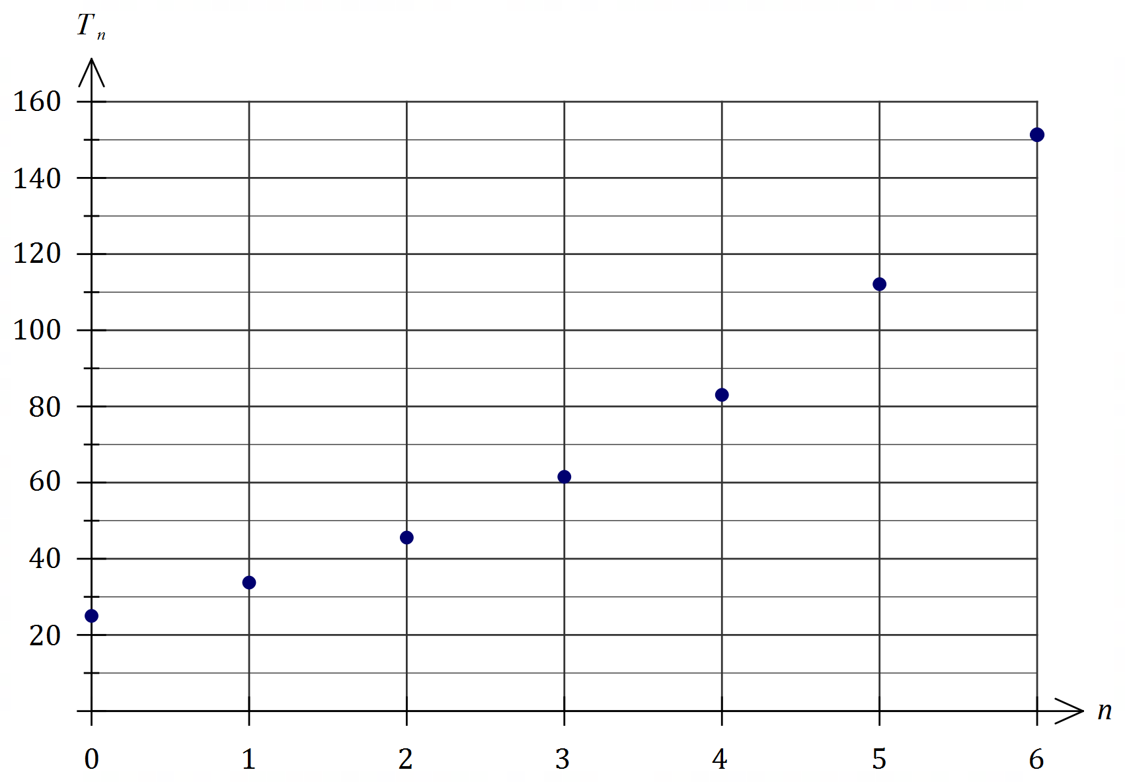

(c) Name the type of growth displayed in the graph. (1 mark)

| **Solution** |
| --- |
| Exponential or Geometric |
| **Specific behaviours** |
| ✔ correct term |

(d) During which minute does the temperature of the kiln first increase by more than ?

| **Solution** |
| --- |
| During the th minute (from to ) |
| **Specific behaviours** |
| ✔ correct minute |

(1 mark)

**Question 17 (8 marks)**

A customer in a store is offered a reducible interest loan that attracts interest of compounded monthly to purchase a computer and accessories. The monthly loan repayment is .

The customer set up the spreadsheet below to analyse the loan, rounding the displayed figures to the nearest cent.

| Month | Balance at start of month ($) | Interest for month | Repayment | Balance at end of month ($) |
| --- | --- | --- | --- | --- |
|  |  |  |  |  |
|  |  |  |  |  |
|  |  |  |  |  |

(a) Complete row of the spreadsheet. (3 marks)

| **Solution** |
| --- |
| See table |
| **Specific behaviours** |
| ✔ opening balance and repayment  ✔ interest  ✔ closing balance |

(b) Determine a simplified recurrence relation for , the loan balance at the start of month .

(2 marks)

| **Solution** |
| --- |
|  |
| **Specific behaviours** |
| ✔ interest multiplier  ✔ recurrence relation and first term |

(c) State the number of repayments required to pay off the loan. (1 mark)

| **Solution** |
| --- |
| repayments |
| **Specific behaviours** |
| ✔ correct number |

(d) Determine the total amount of interest paid over the life of the loan. (2 marks)

| **Solution** |
| --- |
| Total payments: |
| **Specific behaviours** |
| ✔ total payments  ✔ interest |

**Question 18 (9 marks)**

An experiment involved measuring the voltage in a circuit after seconds. The equation of the least-squares line to model the linear relationship between and is given by and .

The residual plot for the linear model is shown below.

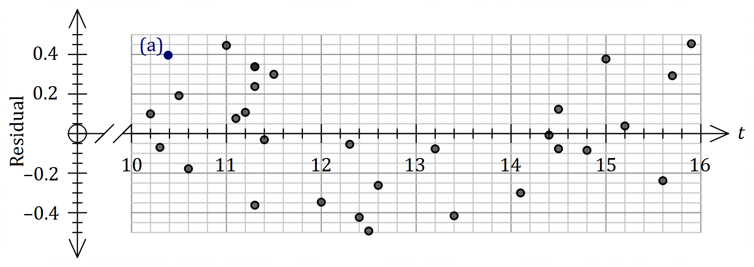

| **Solution** |
| --- |
|  |
| **Specific behaviours** |
| ✔ predicts voltage  ✔ calculates residual  ✔ plots residual |

(a) After seconds, the measured voltage was . Calculate the residual for this point and add it to the plot above. (3 marks)

(b) Explain what information in this question

(i) supports the use of the linear model. (2 marks)

| **Solution** |
| --- |
| The correlation coefficient of indicates a strong association between the variables. |
| **Specific behaviours** |
| ✔ states correlation  ✔ states that correlation is strong |

(ii) does not support the use of the linear model. (2 marks)

| **Solution** |
| --- |
| A pattern is evident in the residuals (tend to change from positive to negative to positive as time increases) which indicates that the linear model is not appropriate. |
| **Specific behaviours** |
| ✔ refers to residual plot  ✔ states a pattern is evident |

(c) The residual for the voltage measured after seconds is shown on the plot above. Determine what voltage was measured at this time. (2 marks)

| **Solution** |
| --- |
|  |
| **Specific behaviours** |
| ✔ residual from plot  ✔ measured voltage [ |

**Question 19 (7 marks)**

An annuity compounds interest annually and its value after withdrawals can be modelled using the recurrence relation

(a) Use the relation to state

(i) the annual percentage interest rate. (1 mark)

| **Solution** |
| --- |
|  |
| **Specific behaviours** |
| ✔ correct value |

(ii) the initial value of the annuity. (1 mark)

| **Solution** |
| --- |
|  |
| **Specific behaviours** |
| ✔ correct value |

(b) Calculate the balance of the annuity, to the nearest dollar, after withdrawals. (1 mark)

| **Solution** |
| --- |
|  |
| **Specific behaviours** |
| ✔ correct value |

| **Solution** |
| --- |
|  |
| **Specific behaviours** |
| ✔ indicates correct method  ✔ correct amount |

(c) The annuity is closed after withdrawals. Calculate the total interest paid by the annuity up to this time. (2 marks)

(d) From the outset, the annual withdrawal can be reduced so that the annuity becomes a perpetuity. Briefly explain what a perpetuity is and determine the withdrawal required.

(2 marks)

| **Solution** |
| --- |
| A perpetuity is an annuity in which the withdrawal equals the interest paid each time period and so the withdrawal can be made for ever.  Withdrawal will be . |
| **Specific behaviours** |
| ✔ satisfactory explanation of perpetuity  ✔ correct new withdrawal |

**Question 20 (10 marks)**

The number of people (, in thousands) studying in Australia with a student visa from to are shown in the graph and table below.

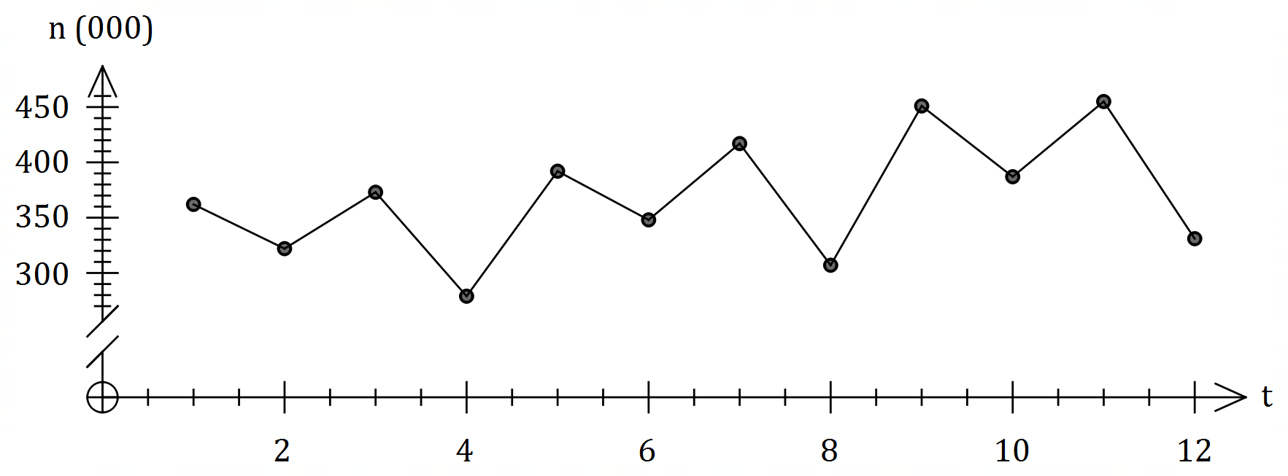

| Year | Quarter | Time () | Number ( 's) | Quarterly mean | Percentage of quarterly mean |
| --- | --- | --- | --- | --- | --- |
|  |  |  |  |  |  |
|  |  |  |  |
|  |  |  |  |
|  |  |  |  |
|  |  |  |  |  |  |
|  |  |  |  |
|  |  |  |  |
|  |  |  |  |
|  |  |  |  |  |  |
|  |  |  |  |
|  |  |  |  |
|  |  |  |  |

(a) Determine the value of , the value of and the value of in the table above. (3 marks)

| **Solution** |
| --- |
|  |
| **Specific behaviours** |
| ✔ value of  ✔ value of  ✔ value of |

(b) Complete the missing values in the seasonal index table below. (2 marks)

| Quarter |  |  |  |  |
| --- | --- | --- | --- | --- |
| Seasonal Index |  |  |  |  |

| **Solution** |
| --- |
|  |
| **Specific behaviours** |
| ✔ one correct value  ✔ both correct values |

(c) Calculate the deseasonalised number of people studying in Australia with a student visa in the fourth quarter of . (2 marks)

| **Solution** |
| --- |
| Number of people is |
| **Specific behaviours** |
| ✔ indicates correct calculation  ✔ correct figure, allowing for thousands |

Let represent all the deseasonalised values of . The equation of the least-squares line for against is given by .

(d) Determine an estimate for the number of people studying in Australia with a student visa in the fourth quarter of if the existing trend and seasonality continues. (3 marks)

| **Solution** |
| --- |
|  |
| **Specific behaviours** |
| ✔ uses  ✔ correct value of  ✔ correct estimate, allowing for thousands |

**Question 21 (10 marks)**

A reverse mortgage is a loan that allows a person to borrow money using their home as security. Interest is charged like any other loan, but no repayments are made - the interest compounds over time and is added to the loan balance.

At the start of January , a borrower takes out a reverse mortgage for at an interest rate of per annum, compounded monthly.

(a) State a simplified recurrence relation for , the loan balance after months. (2 marks)

| **Solution** |
| --- |
|  |
| **Specific behaviours** |
| ✔ interest multiplier  ✔ recurrence relation |

(b) Determine the loan balance at the start of January . (2 marks)

| **Solution** |
| --- |
| Interest periods |
| **Specific behaviours** |
| ✔ number of periods  ✔ correct balance |

(c) Determine the effective interest rate of the reverse mortgage, correct to decimal places.

| **Solution** |
| --- |
|  |
| **Specific behaviours** |
| ✔ correct rate |

(1 mark)

The borrower's home was valued at at the time they took out the reverse mortgage and was expected to appreciate at a rate of per annum.

(d) Use a recurrence relation to determine the value of the home at the start of January .

(2 marks)

| **Solution** |
| --- |
|  |
| **Specific behaviours** |
| ✔ use of recurrence relation  ✔ value that rounds to figure shown |

(e) At the start of which calendar year will the loan balance first exceed the value of the home? Justify your answer. (3 marks)

| **Solution** |
| --- |
| After **years**, loan balance:  Loan first exceeds value at the start of year 2044. |
| **Specific behaviours** |
| ✔ indicates method  ✔ shows will take 25 years  ✔ correct year |

Supplementary page

Question number: _________

Supplementary page

Question number: _________

© 2019 WA Exam Papers. Kennedy Baptist College has a non-exclusive licence to copy and communicate this document for non-commercial, educational use within the school. No other copying, communication or use is permitted without the express written permission of WA Exam Papers. SN245-146-4.